
CMP505.516

Technical Report – Route C

Name: Zoey McCall

Title: Fungus Generator

Output Route C

Project Type Individual

Project Contributors and Roles Zoey McCall - Developer

Part 1: Technical Proposition

This project outlines the development of a procedural fungus/organic growth generator, built as a Houdini Digital Asset (HDA) for deployment in Unreal Engine and Unity via the Houdini Engine plugin. This tool provides a method of configuring a simulated fungus growth over any given mesh. This project is aimed towards technical artists and game developers looking to generate organic fungus-like structures over 3D meshes without leaving the game engine.

The system contains the following key features:
- Arbitrary Mesh Input: Uses Houdini Engine geometry inputs, accepting any Static Mesh as the input for the simulation
- Scale Normalisation: Normalises incoming geometry into a 1x1x1 bounding box prior to simulating. All fungus variables remain consistent on any geometry scale.
- Surface Adhesion: VEX ray casting (minPos) forces fungus particles to stick to the mesh, growing outwards from it.
- Particle Simulation: Primary POP Network used to simulate main fungus growth along the mesh. Secondary POP network used to spawn secondary branching “tendrils” from the main body.
- Volumetric Meshes & UVs: Converts particle simulation into VDB volumes, tapers volumes based on user-input (pscale), and procedurally generates UVs per-frame for texturing in-engine.
- Artist-Driven: Exposes parameters such as Growth Amount, Branching Threshold, Simulation seed, volume thickness etc. Developers in Unreal can iterate and customize the HDA to their needs.

One key constraint during development was usability for animated growth. As Unreal can’t natively import all frames of the live simulation efficiently, the tool provides a variable to freeze time (using TimeShift node). This gives the Engine user a static fungus mesh that can apply over their input object, however does not allow for animated growth in-engine.
The primary success criterion was to generate clean organic-like structures over any given input mesh with valid UVs. Extra features consisted of exposing more variables to the HDA, allowing artists more control.

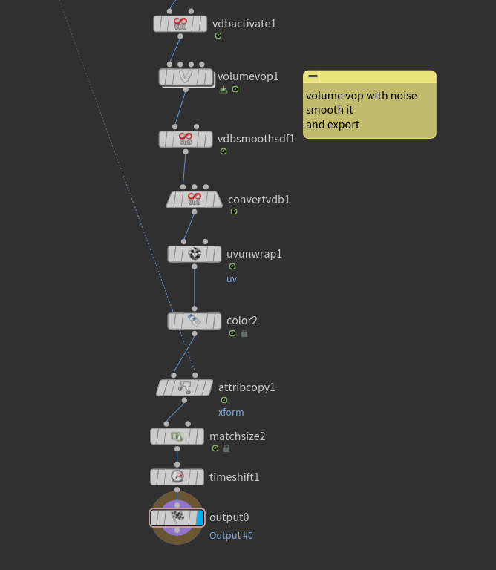
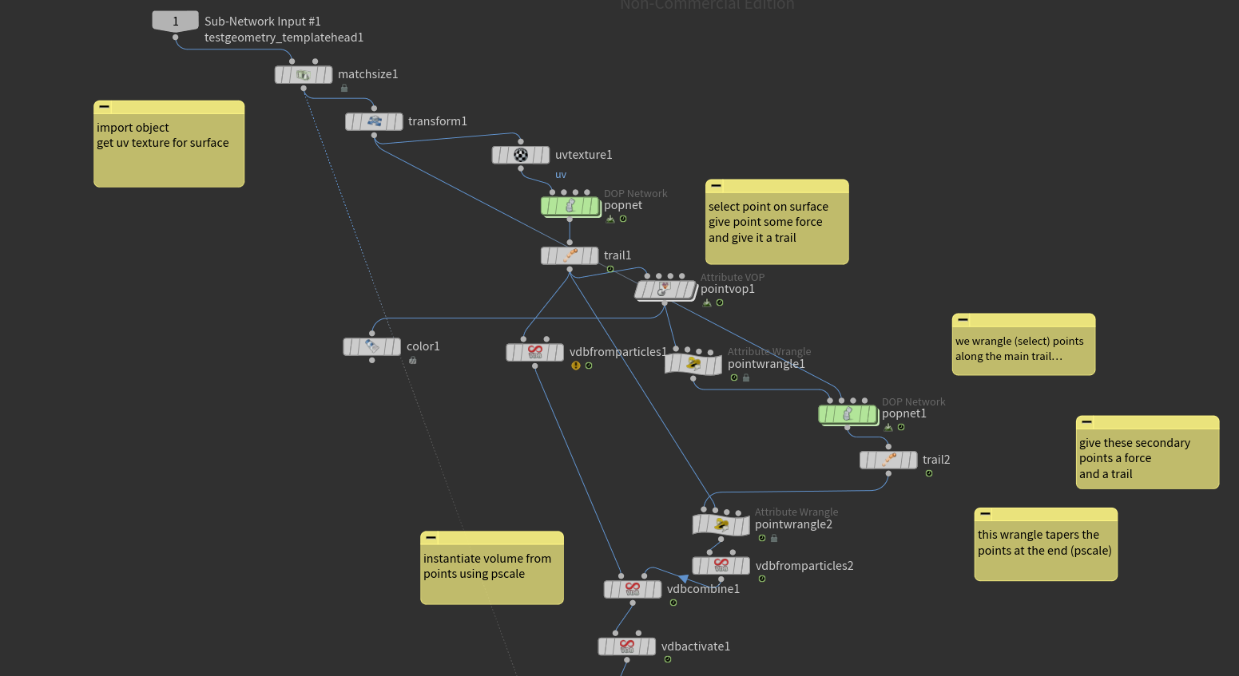
Part 2: High-Level Design Diagram

Inputs -> Processing -> Outputs
- Inputs: The HDA takes an external Static Mesh as the only necessary input, as well as User-defined HDA parameters (Growth Amount, Simulation Seed).
Part 3. A Single Deep Dive

[Deconstruct one focused technical element from your project. – see guidance]

[Any images or works should be referenced.]

[200-600 words]

Part 4. Evidence and Evaluation

[Evidence-based summary of whether the work meets its goals. Complete table – see guidance]

Criterion | Evidence | Status (Met / Partial / Not)
[Criterion 1] | [Evidence] | [Met / Partial / Not]
[Criterion 2] | [Evidence] | [Met / Partial / Not]
[Criterion 3] | [Evidence] | [Met / Partial / Not]

[Write 2–4 sentences interpreting the evidence (what the results show). Do not repeat your broader Part 5 reflection here – see guidance]

[Any images or works should be referenced.]

[200 words]

Part 5. Reflection

[Critical self-reflection on key learning and personal development – see guidance]

[300-600 words]

Multimodal Reference List

Nikita Kuvaev (2023) How to make The Last Of Us fungus (cordyceps) from intro in Houdini Available at: https://www.youtube.com/watch?v=73hNQyvqc4c

